PROTOTYPE EXTENSION
User interface design of the extended Smart Safety companion prototype using MIT app inventor
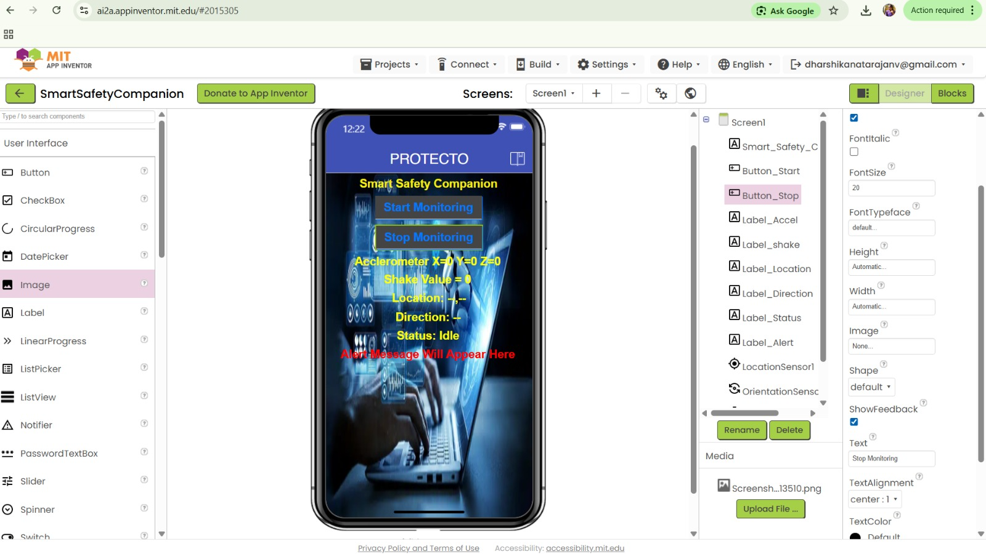
The screenshot shows the MIT App Inventor design environment for an app named smart_safety_companion.
The central Screen1 simulates a phone UI with a blue header titled “Smart Safety Companion”. It contains:
- A Text Box for entering an Emergency number.
- Two oval Buttons labelled “start” (blue) and “stop” (red).
- Several Labels displaying sensor data:
- Accelerometer readings (X=0, Y=0, Z=0).
- Shake value (0).
- Location (blank).
- Direction (blank).
- Status (“Idle”).
- An alert message placeholder (“Alert Message Will Appear Here”).
- A background image of a CCTV camera on a tech‑styled backdrop.
- A clock widget showing 12:20.
The right panel lists the screen’s components (TextBox2, Button1, Button2, various Labels, Accelerometer Sensor, Clock1) and their properties (alignment, background, orientation set to “Unspecified”). The left panel shows available UI components that can be dragged into the designer.
The app appears to be a safety prototype that uses accelerometer (shake) and location sensors to trigger alerts, with emergency contact functionality.
Block – level implementation of accelerometer, location and alert logic in the extended prototype
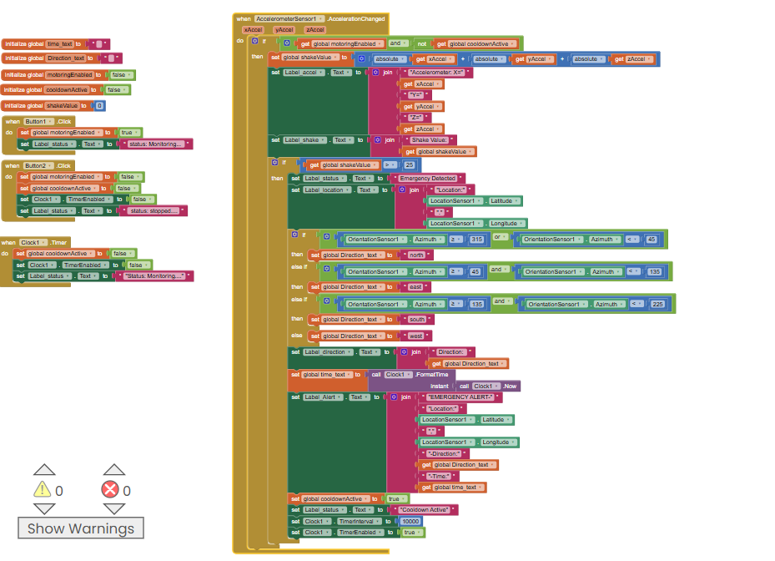
The MIT App Inventor blocks implement a safety‑alert app that:
1. Starts monitoring when Button1 is clicked (sets monitoring Enabled).
2. Stops monitoring with Button2 (clears monitoring Enabled).
3. Accelerometer Sensor detects shake; if monitoring is on and no cooldown is active, it:
- Computes a shake value from X/Y/Z.
- Shows “Emergency Detected” status.
- Fetches location (lat/long) and device direction (azimuth‑based north/east/south/west).
- Displays an alert message with location, direction, and timestamp.
4. Cooldown (10 s) is triggered after an alert to prevent repeated triggers.
5. Clock manages the cooldown timer and resets states.The app uses sensors to detect emergencies and send location‑based alerts with start/stop control.

This is the process while connecting the application via phone :
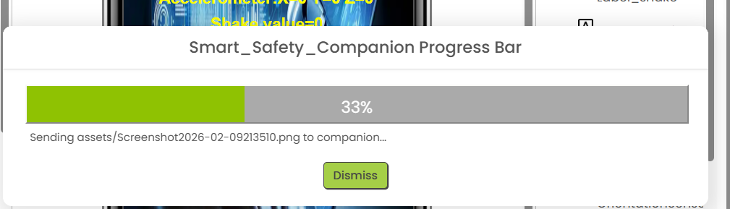
Output screen of Smart Safety Companion showing emergency detection and real-time sensor data:
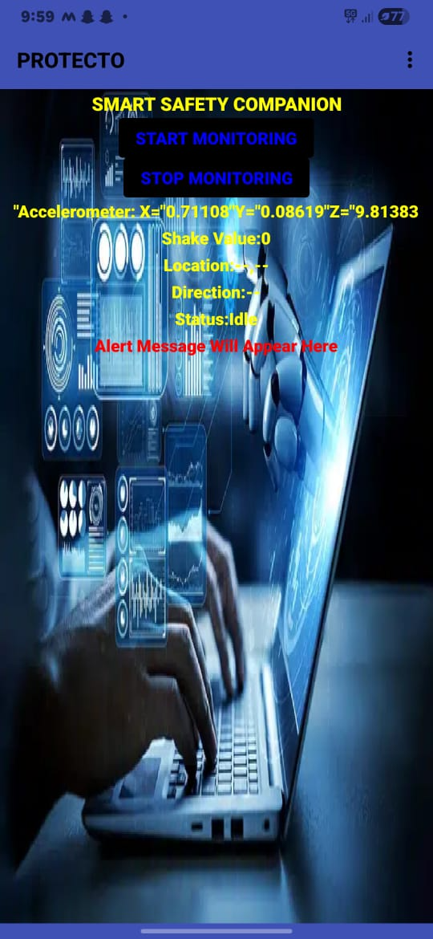

Conclusion:
The Smart Safety Companion application effectively uses mobile sensors to detect emergency situations and provide timely safety alerts. By capturing movement, location, and time details, the app enhances personal security in a simple and user-friendly manner. This project demonstrates the practical use of sensor-based technology for real-world safety applications.

